**ASSIGNMENT**

**MODULE-4**

**AUTOSCALING**

**DONE BY**

**RANJITH KUMAR**

**Tasks To Be Performed:**

1. Create a web server AMI with Apache 2 server running in it.

2. Create a launch configuration with this AMI.

3. Use this launch configuration to create an Auto Scaling group with 1

minimum and 3 maximum instances.

STEP 1 : Open EC2 from as services

STEP 2 : Select launch instances

STEP 3: Give the necessary information to run a web server AMI with Apache 2 server running in it.

STEP 4 : Click Launch instance

STEP 5 : EC2 instance created with apache 2

STEP 6 : Now select the instance , Go to Actions>Image

STEP 7 : Create an image for the ec2 instance

STEP 8 : Select Launch Templates

STEP 9 : Give name , AMI , instance type , keypair , networks and click

Create launch template

“I used launch template instead of launch configuration”

STEP 10 : Select Auto scaling

STEP 11 : Give the needed details till step 7 in creation of auto scaling group and click create auto scaling group

STEP 12 : Created a auto scaling group

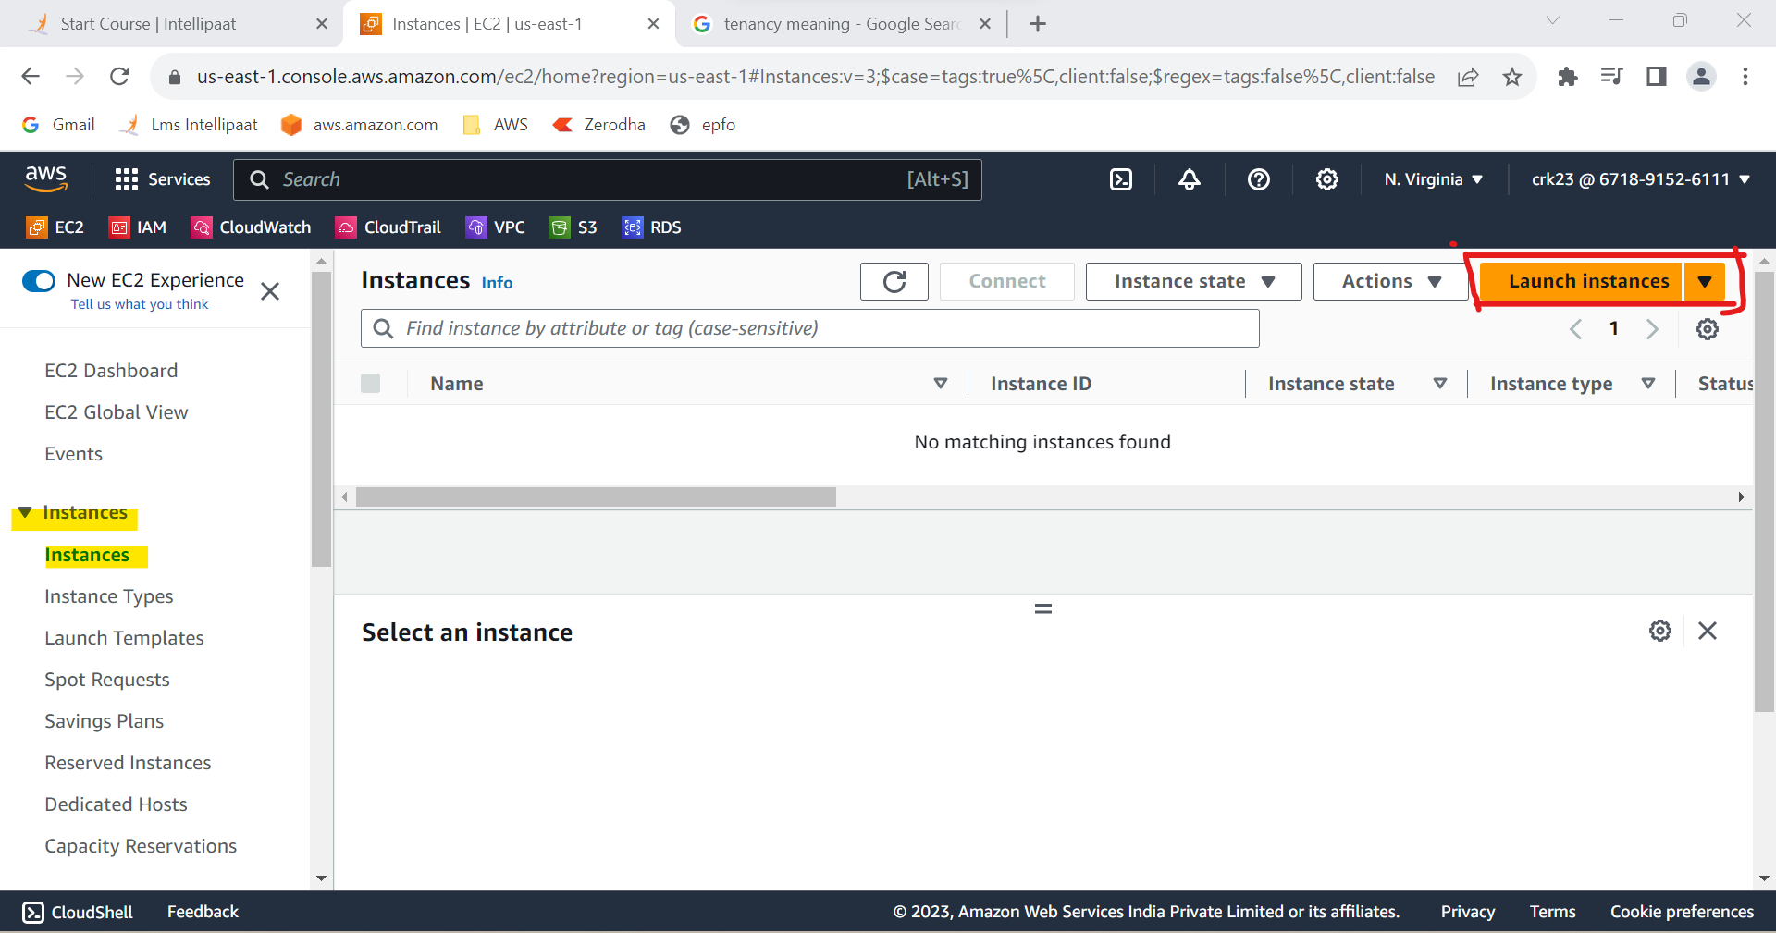

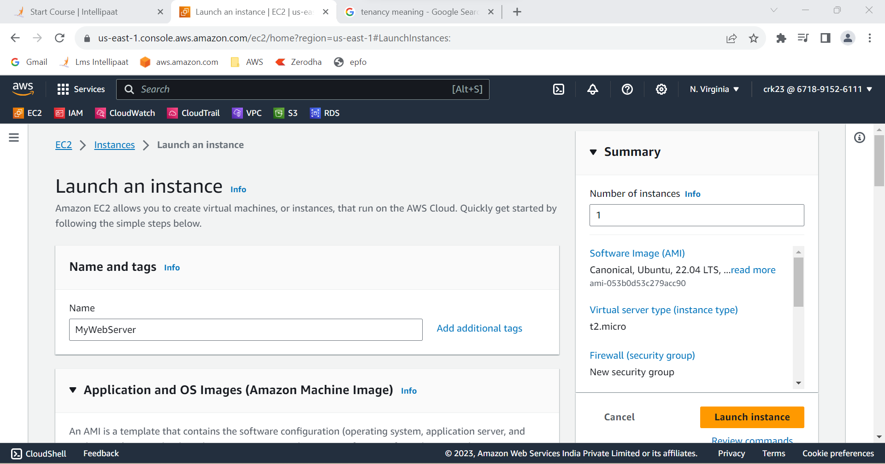

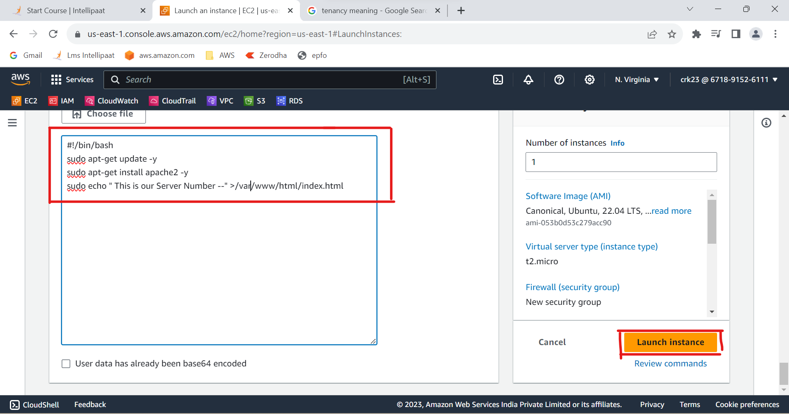

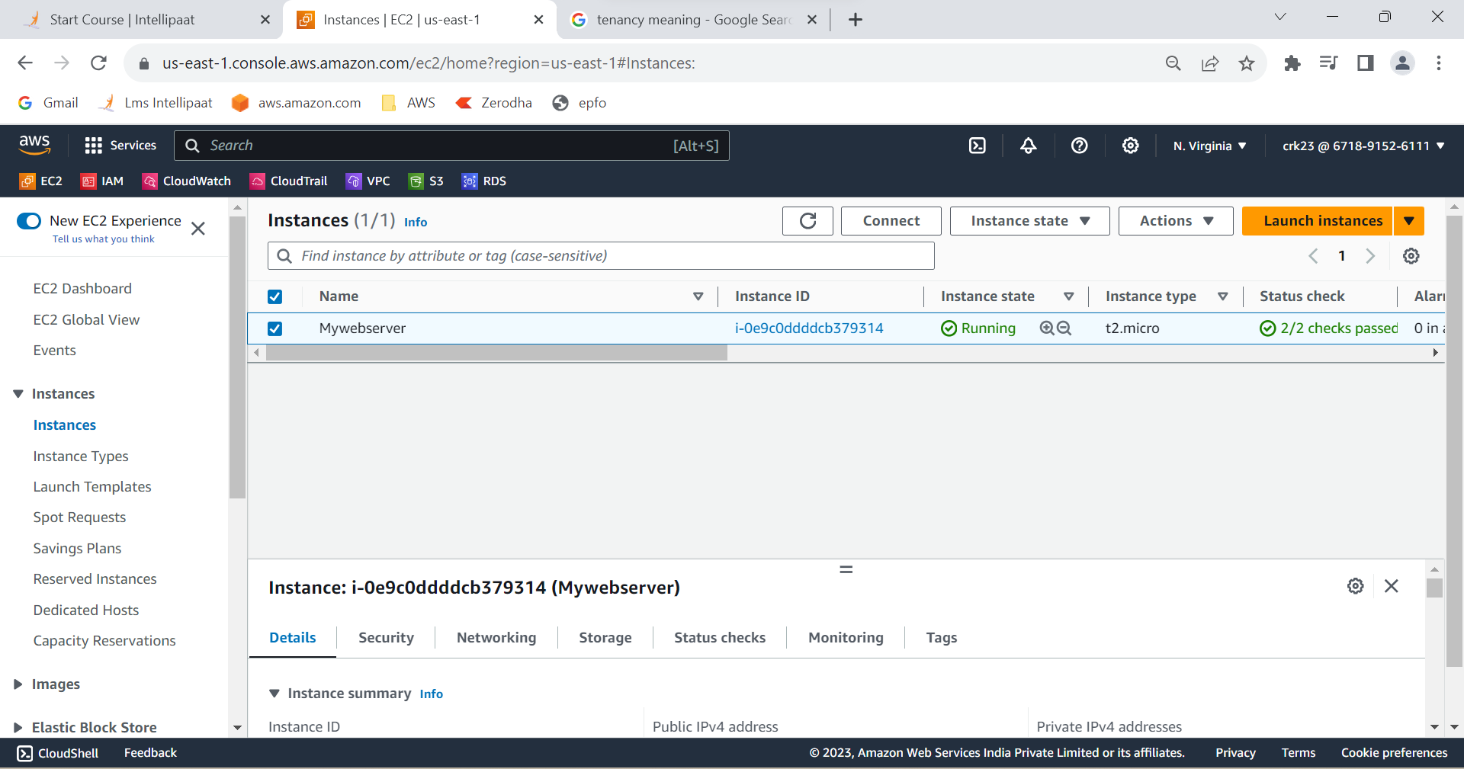

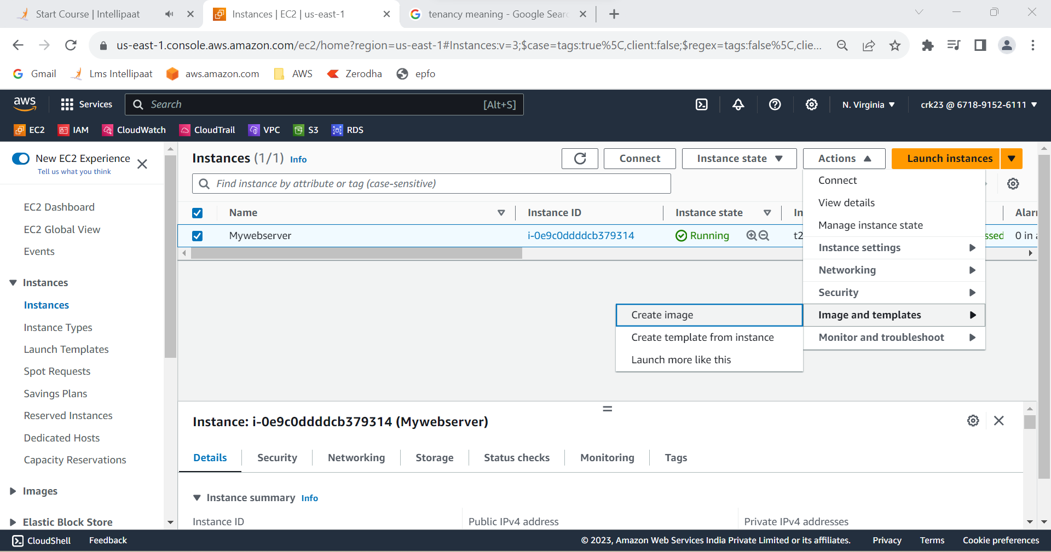

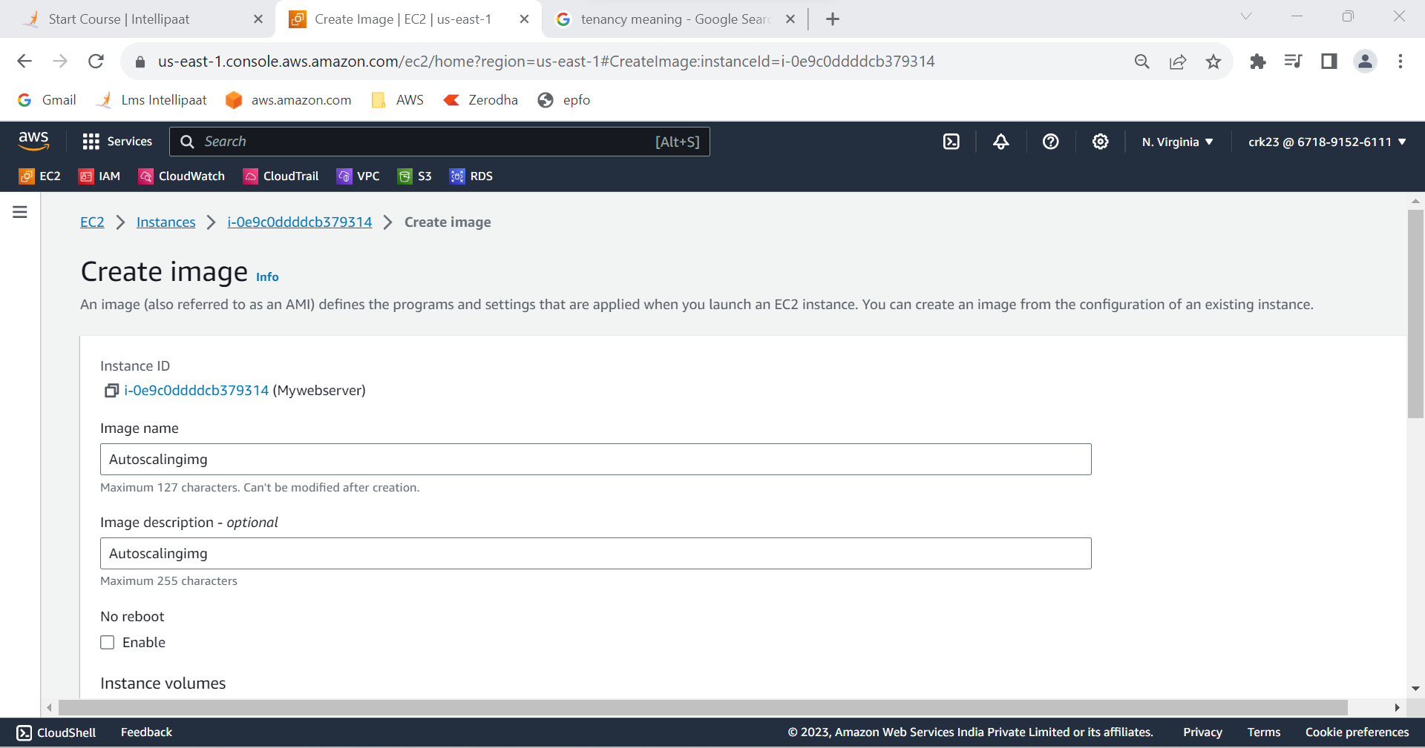

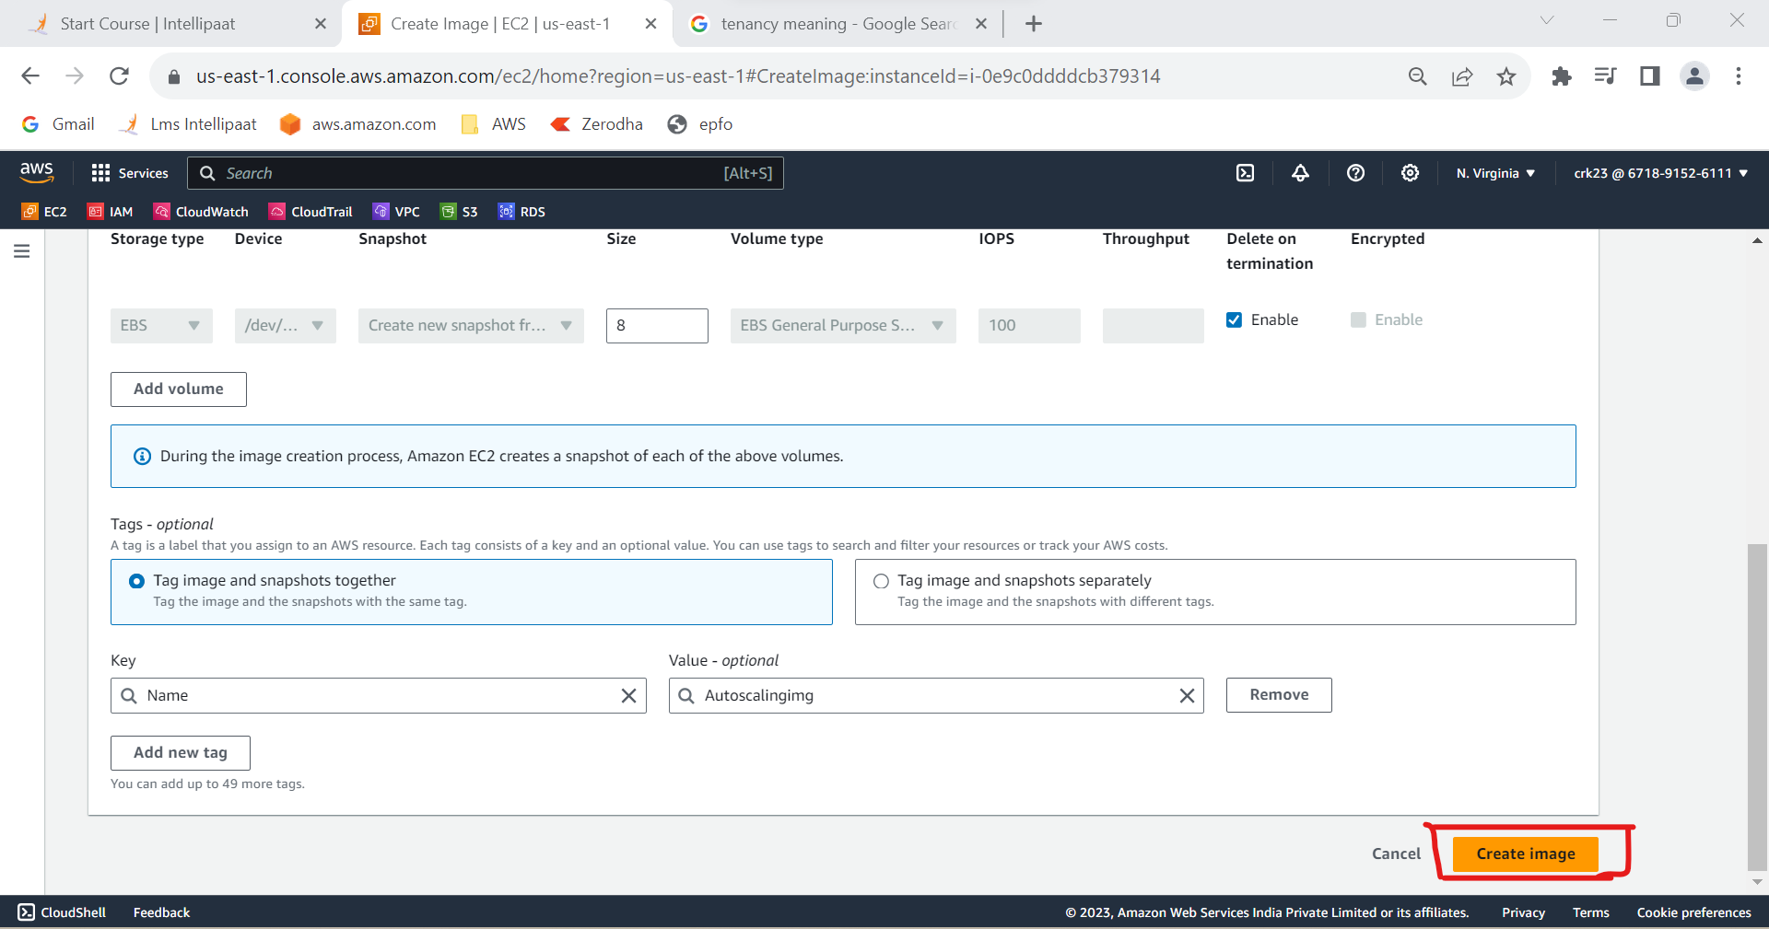

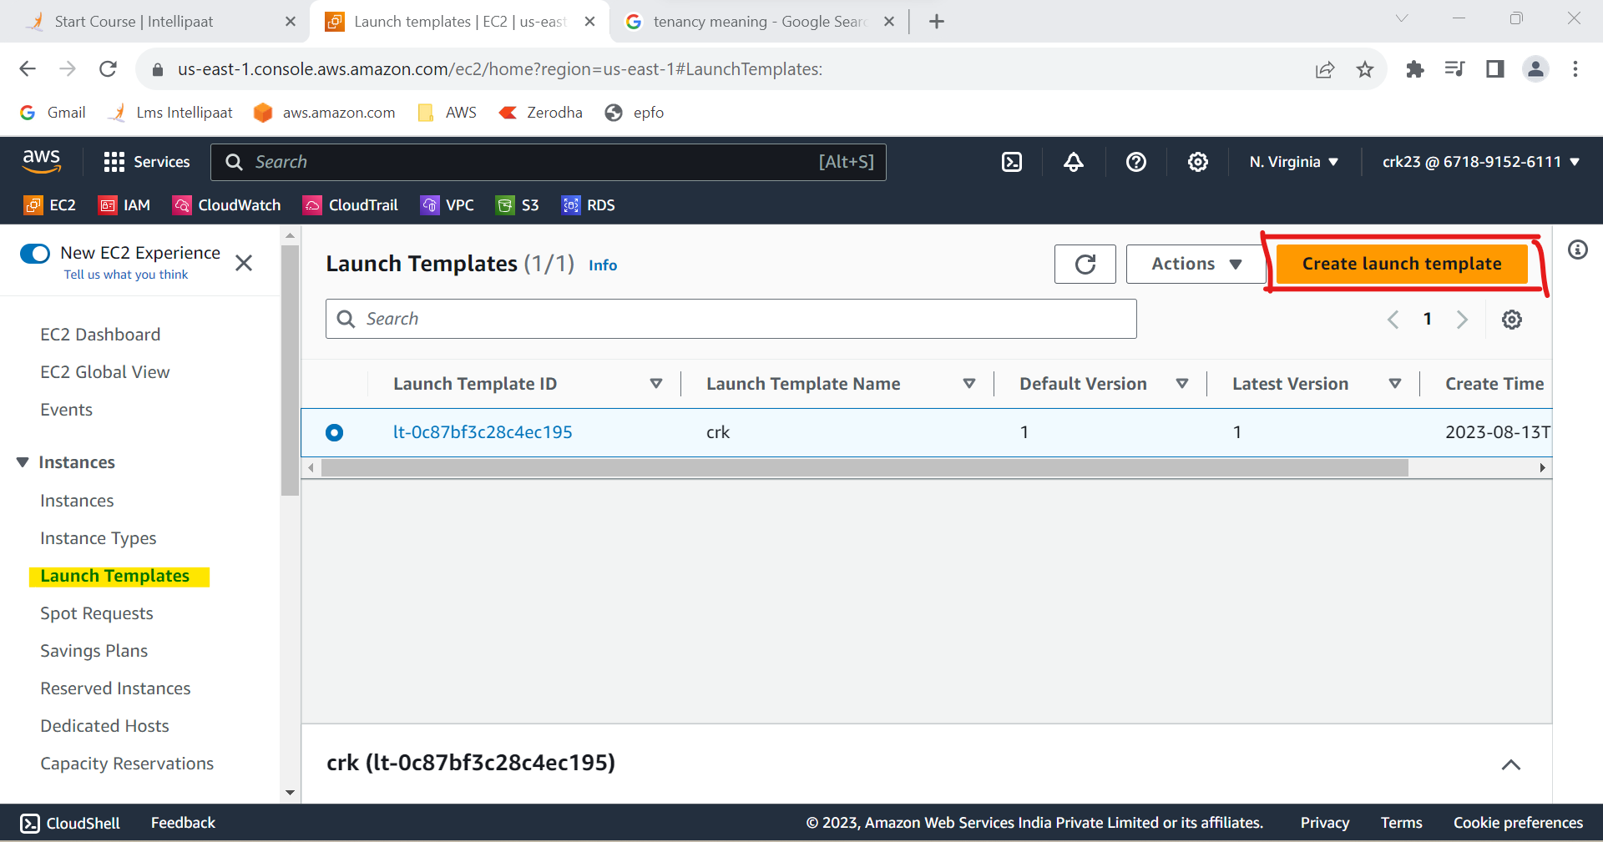

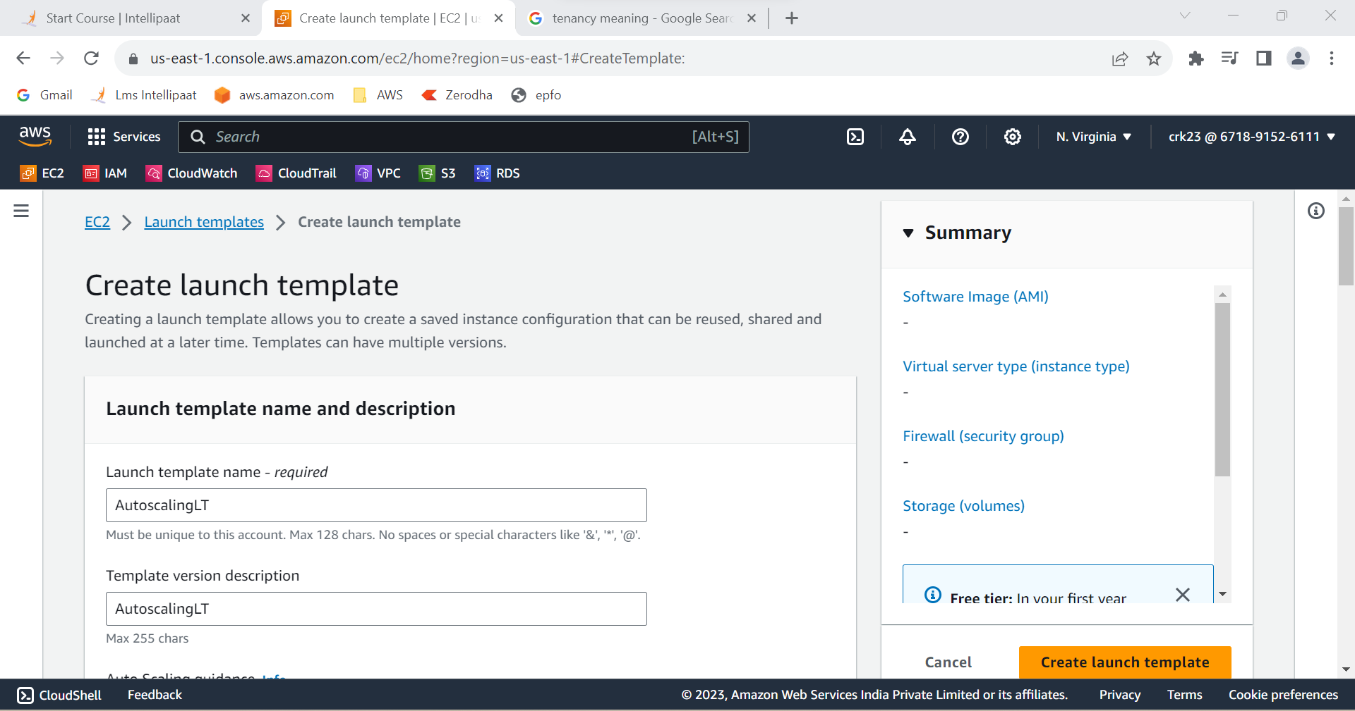

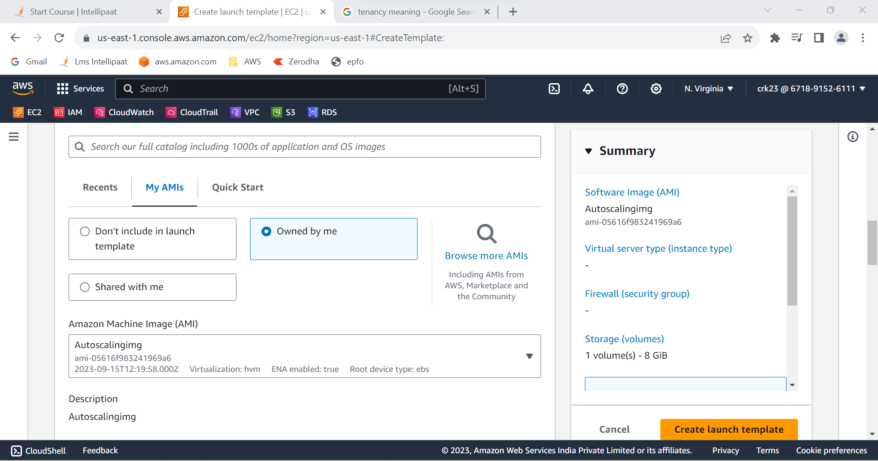

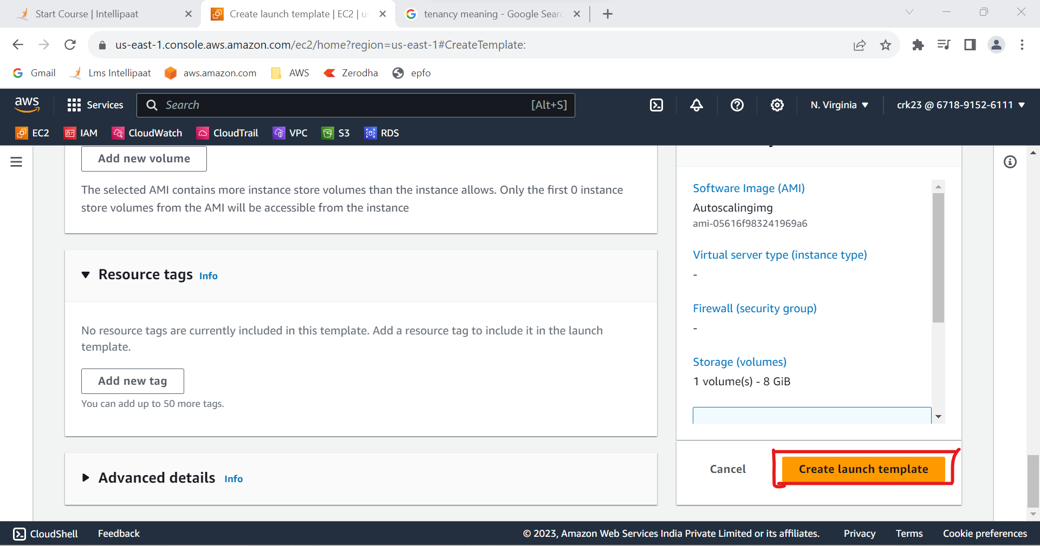

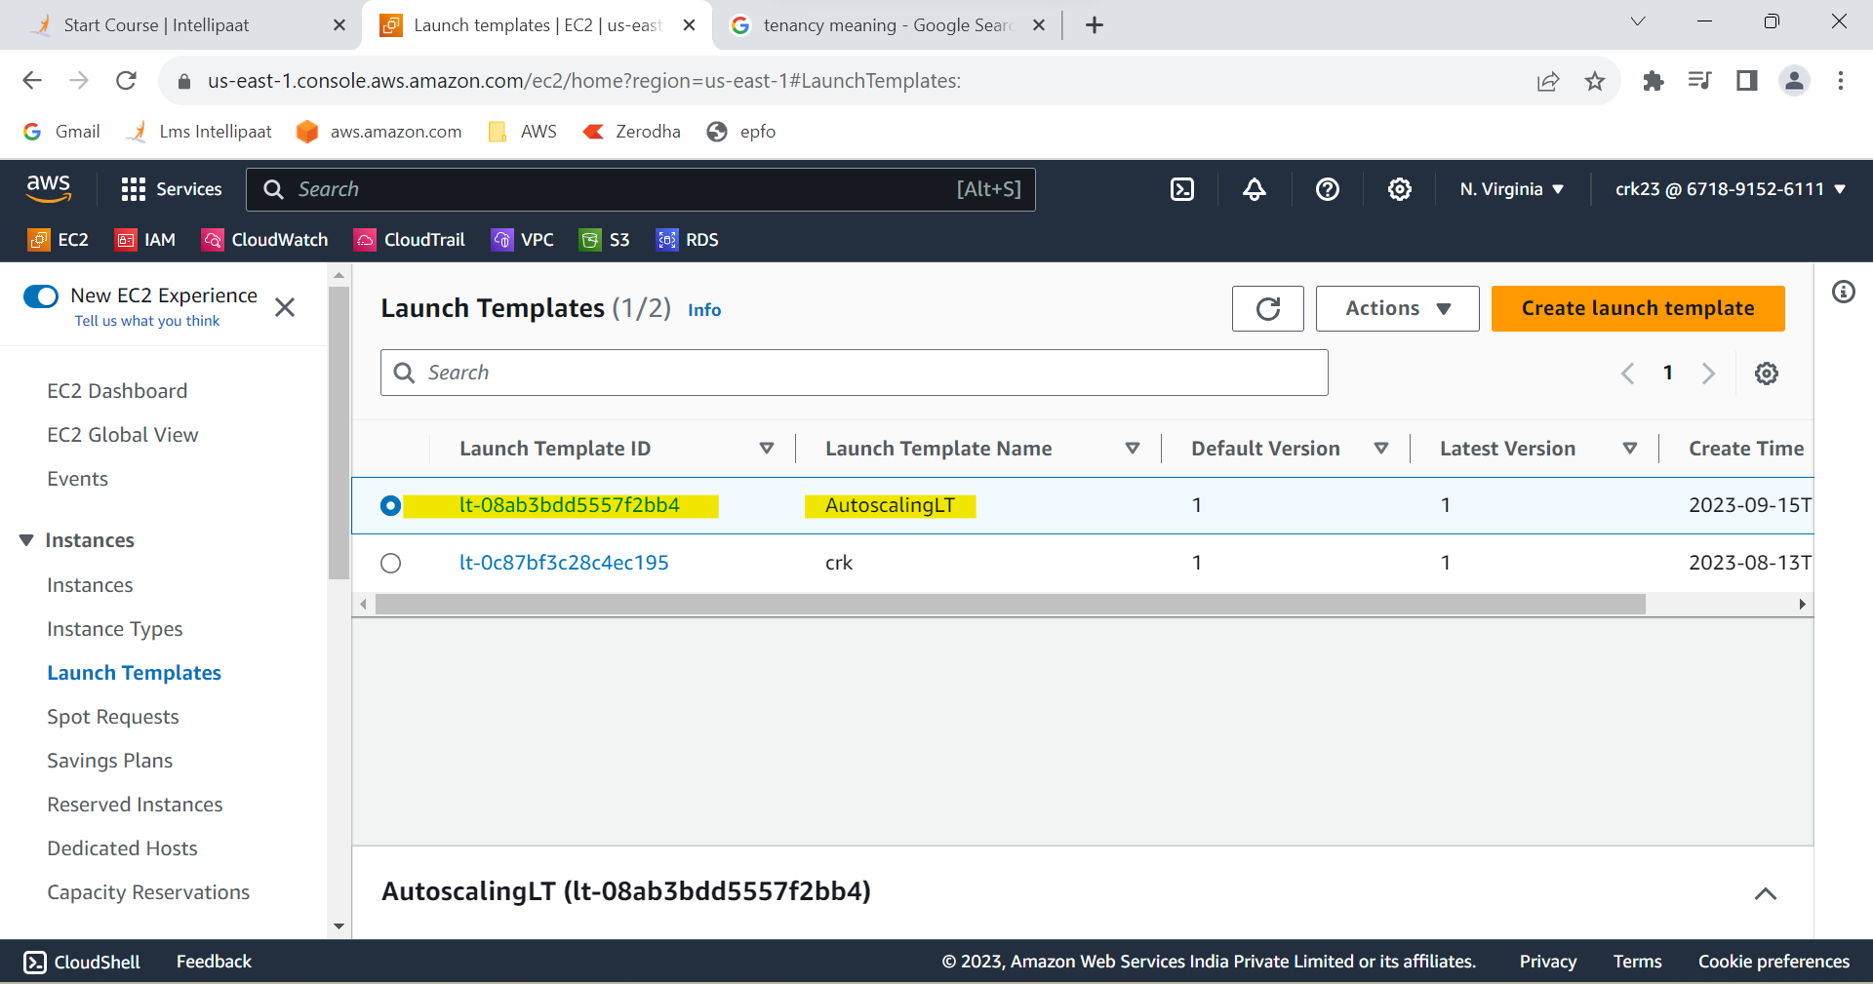

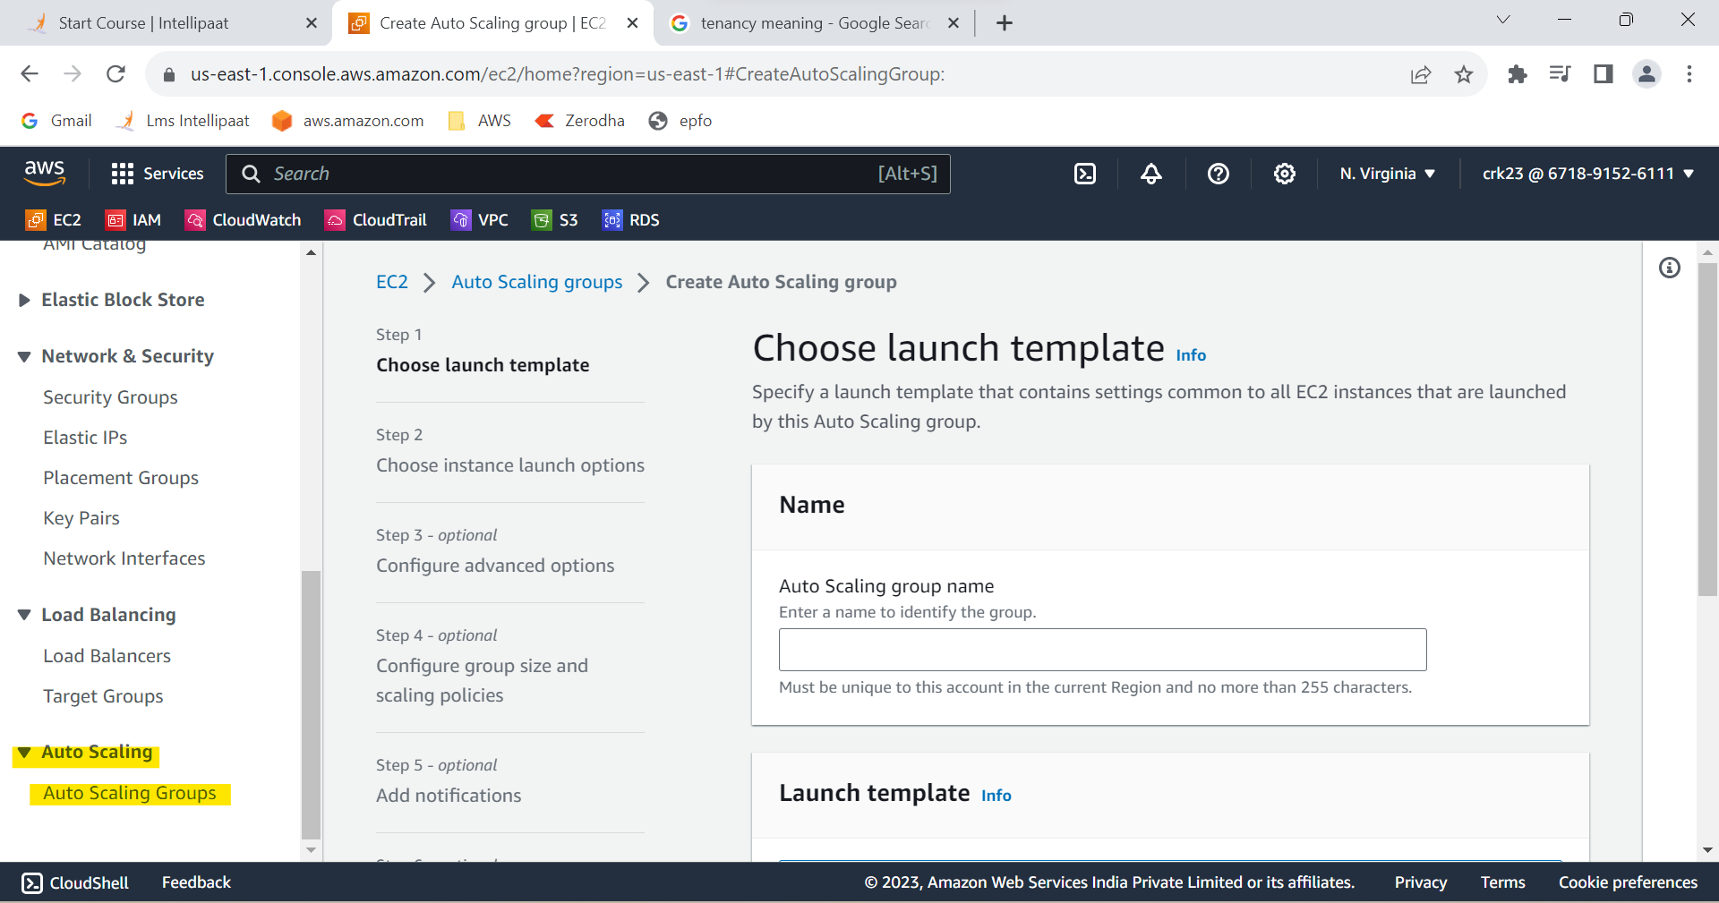

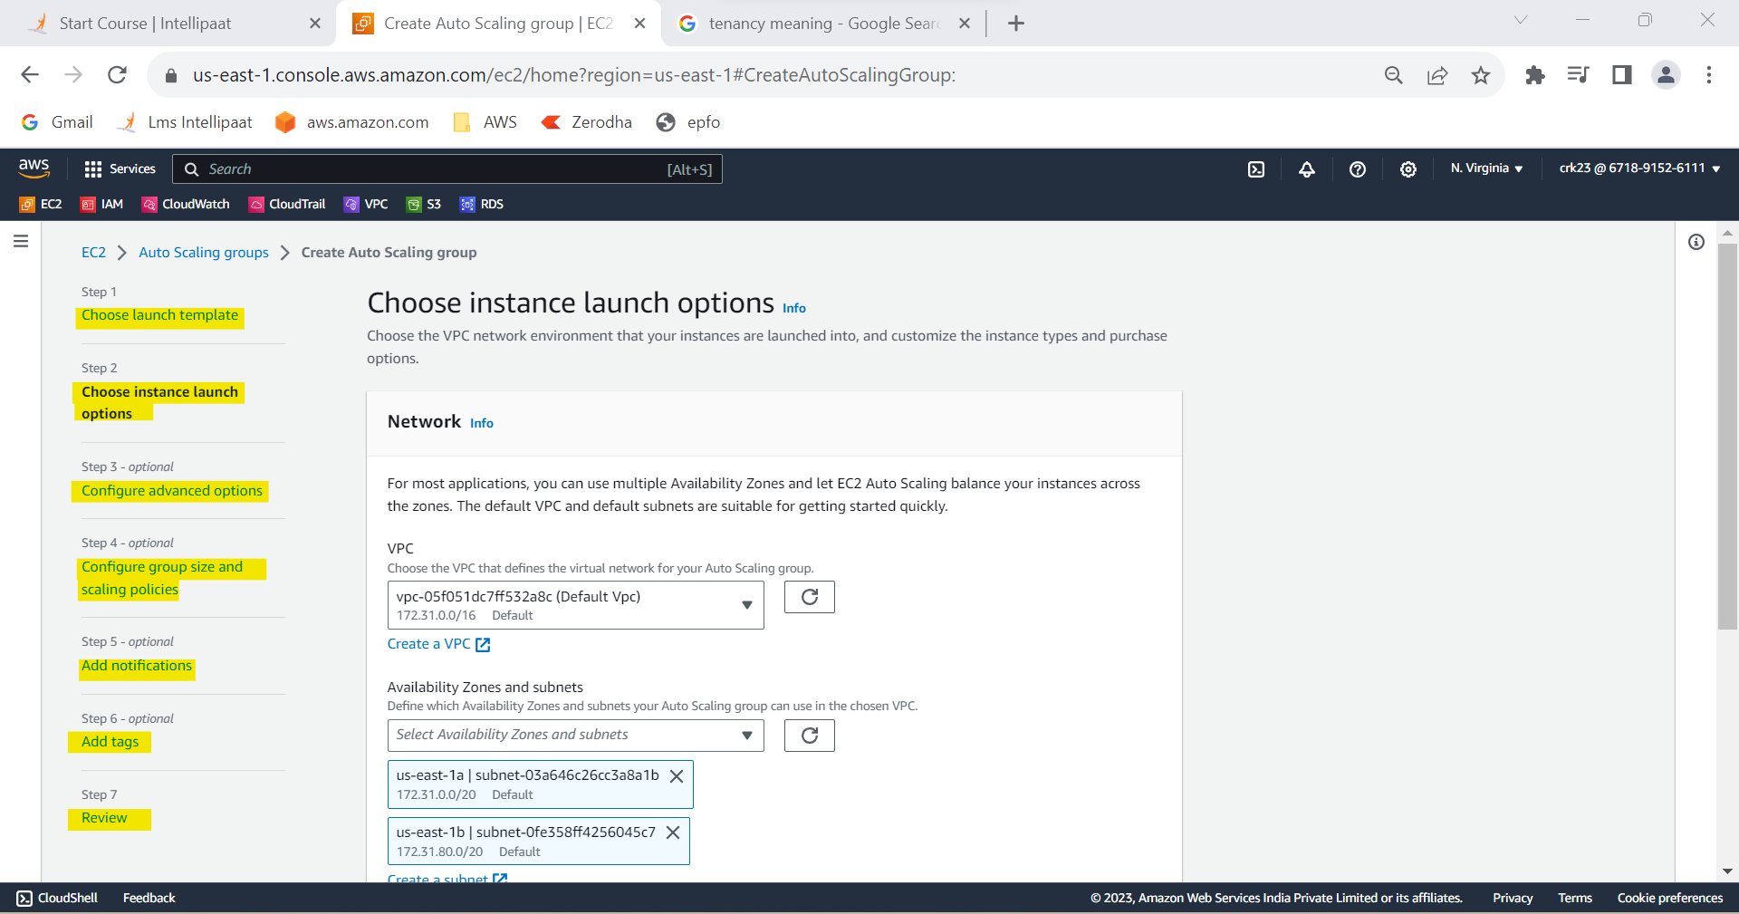

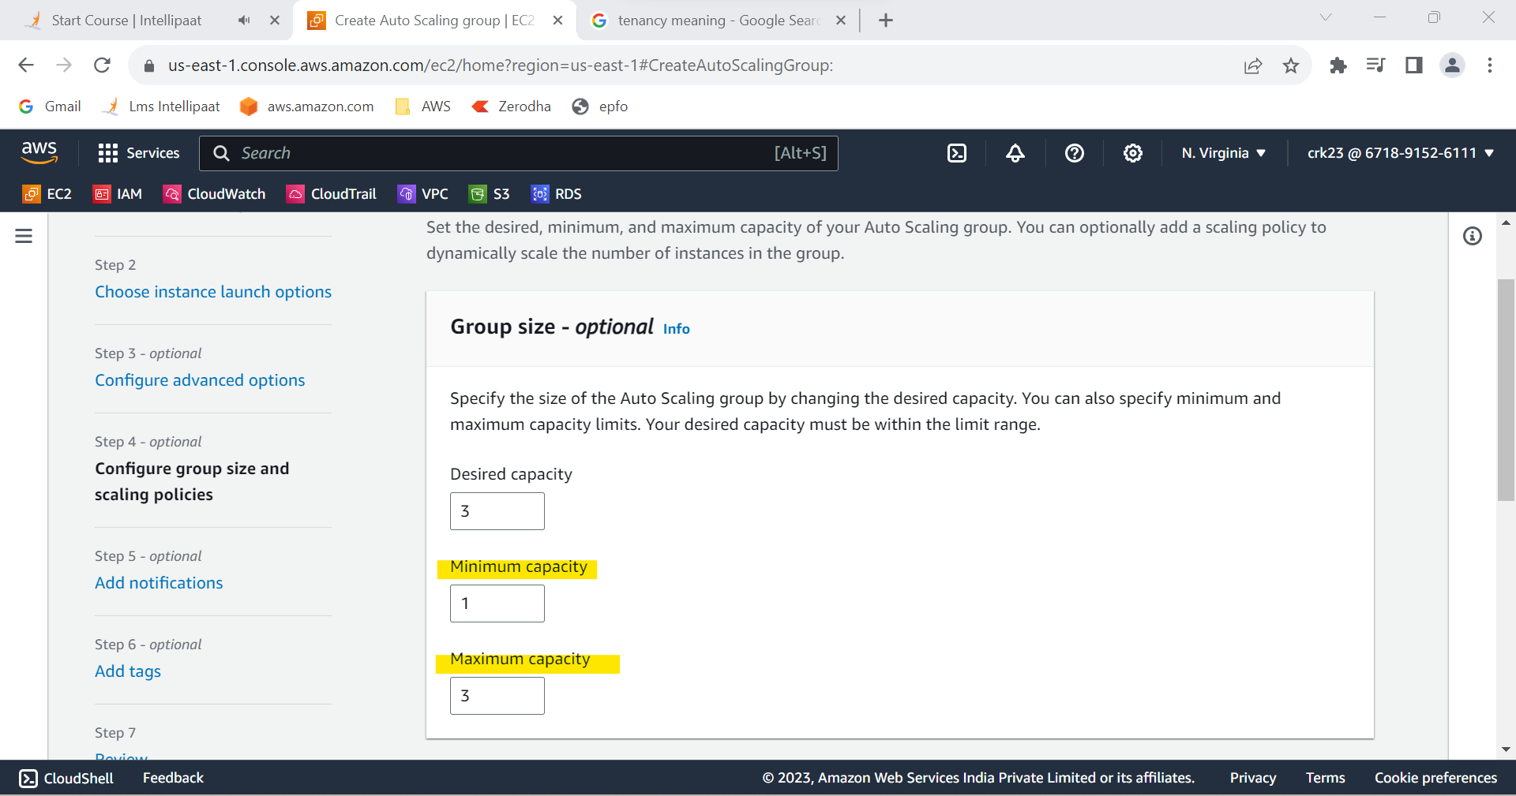

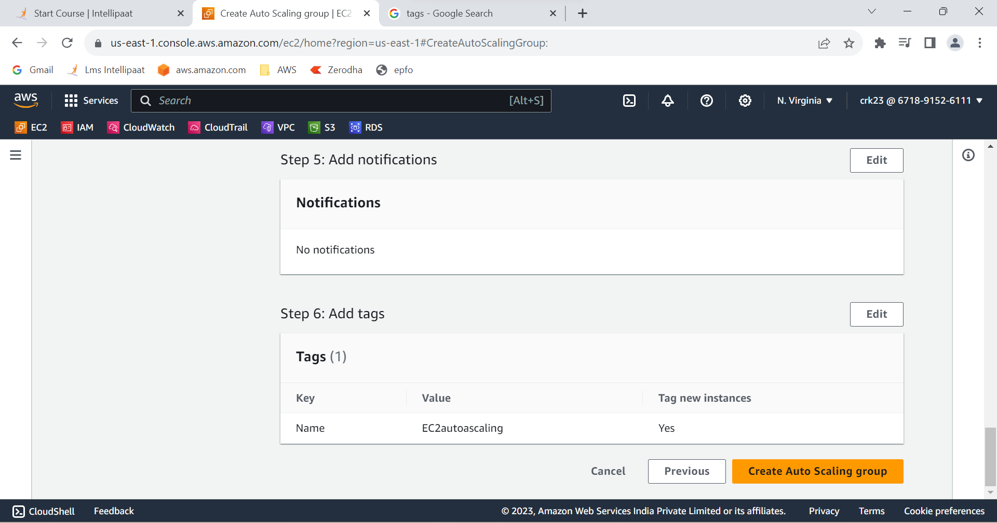

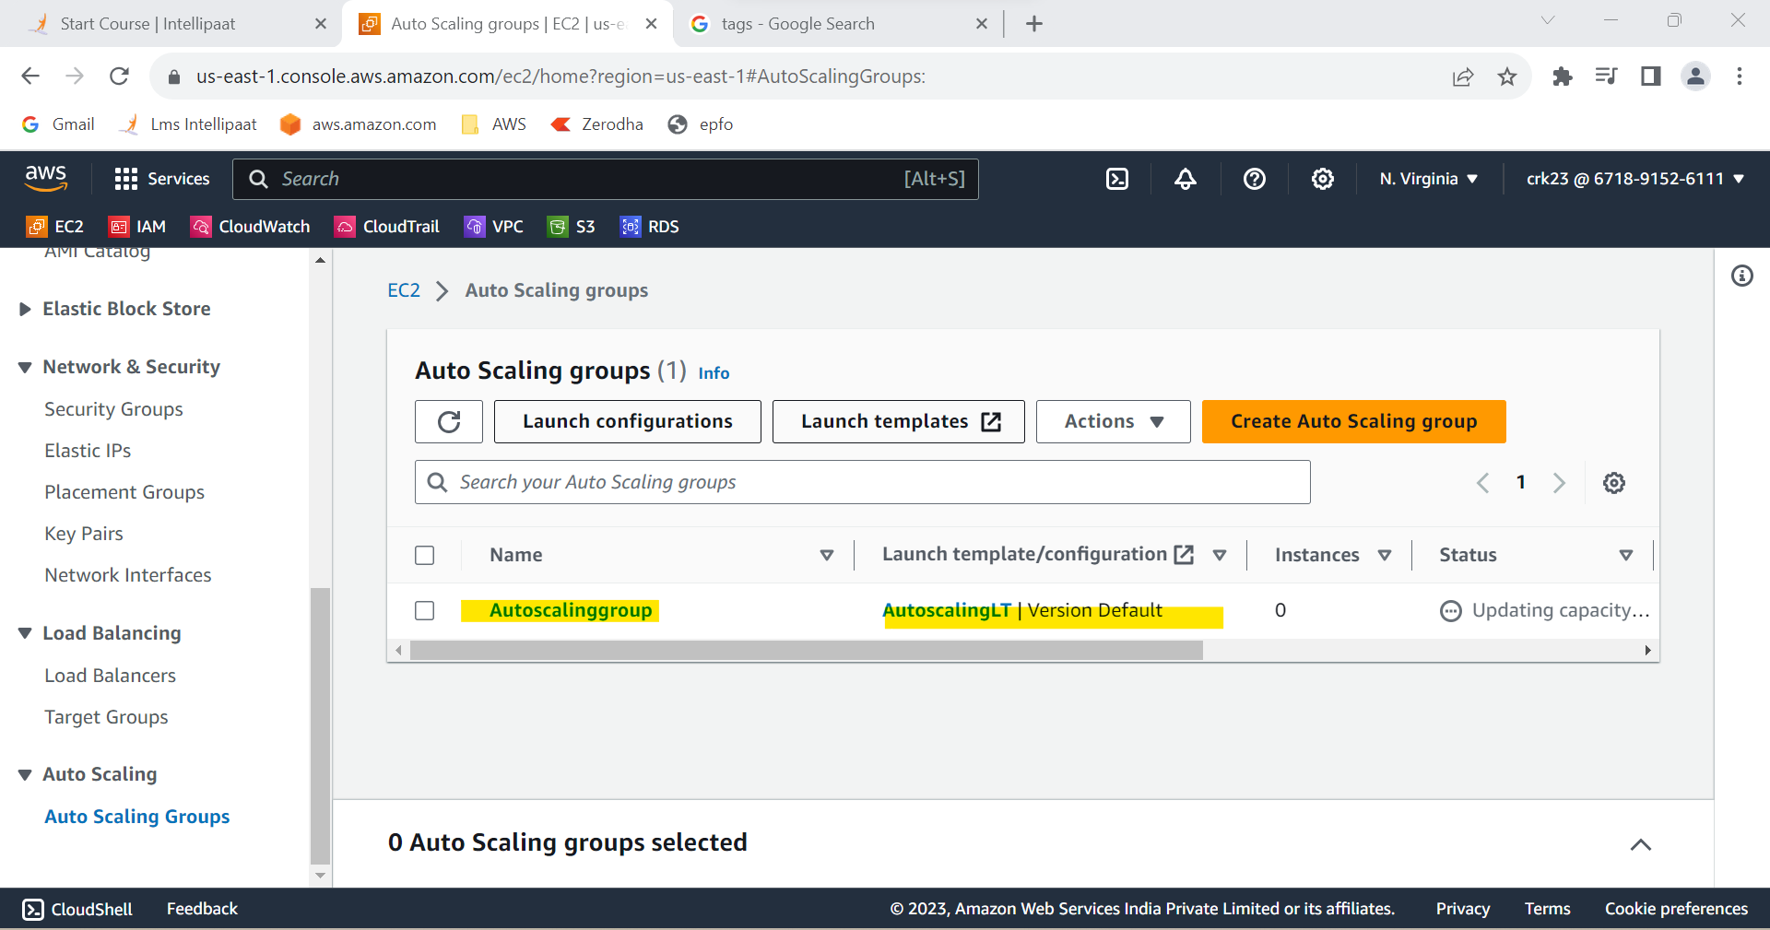

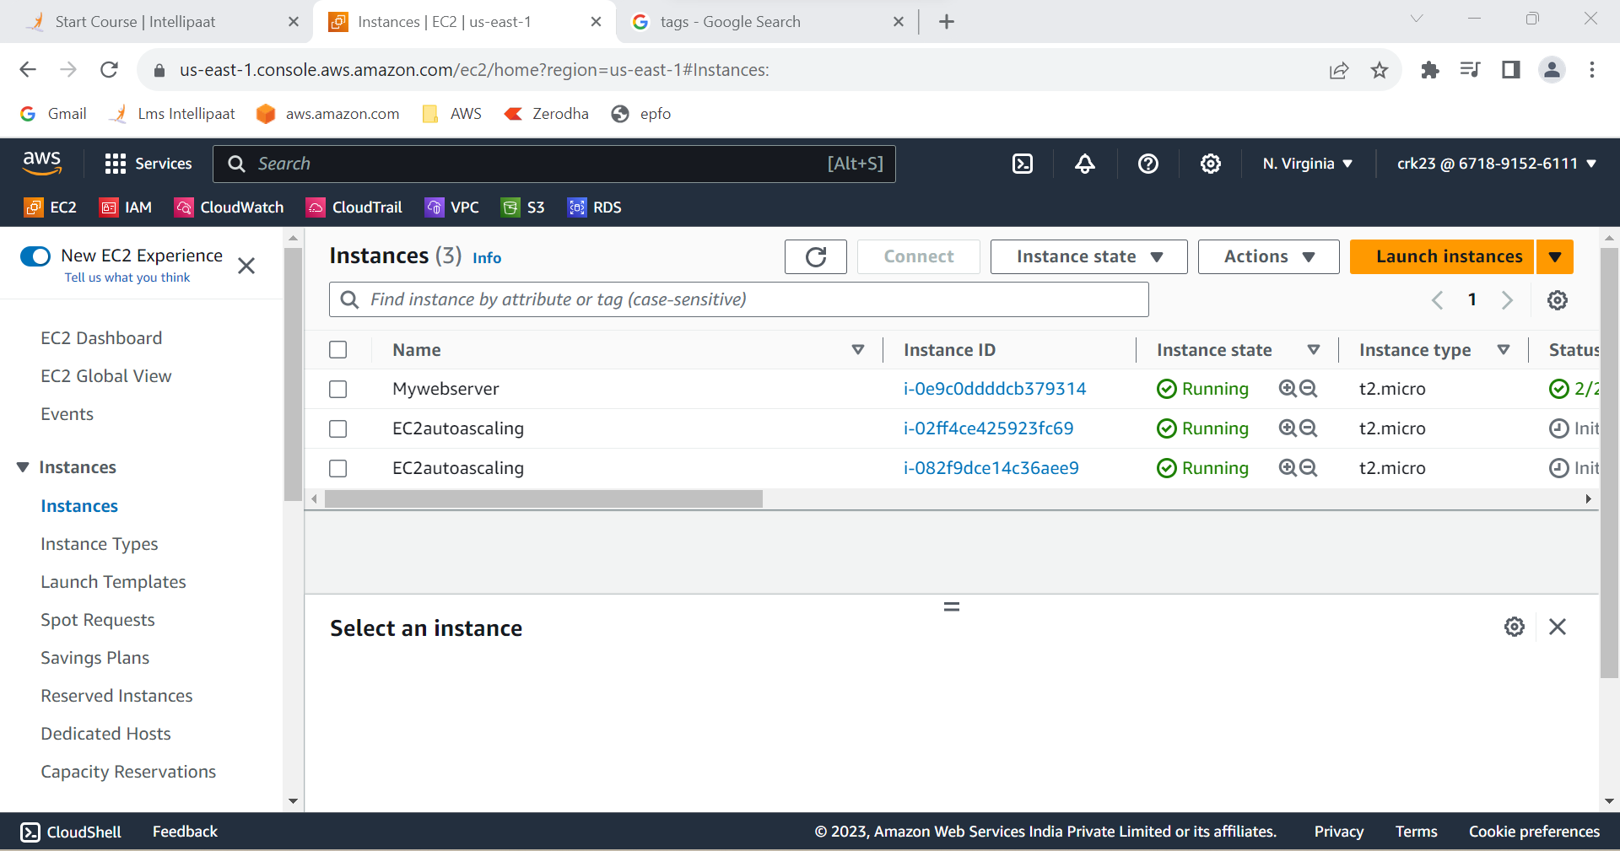

**OUTPUT :**

Created a web server AMI with Apache 2 server running in it ,

Created a launch template with this AMI & Used the launch template to create an Auto Scaling group with 1 minimum and 3 maximum instances.